In this activity we will be installing and configuring an enterprise class firewall platform based on the FreeBSD operating system. The processes and configurations are very similar to any number of enterprise class firewalls. There are many pages in this activity, but the overall process does not take very long – the pictures are there to help you. Pay close attention to the interface configuration section.

To begin, copy the “*pfSense-CE-2.7.0-RELEASE-amd64.iso*” file from the U:\ISOs location to the D: drive.

Open VMWare Player in the Start Menu

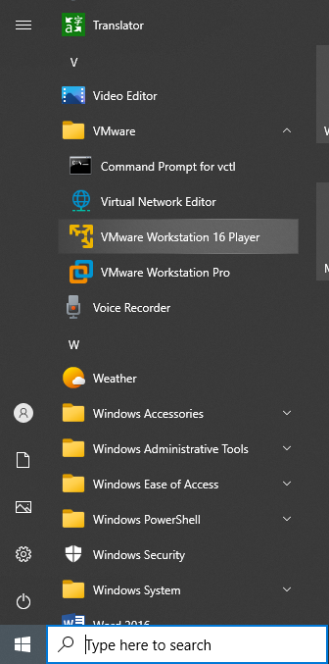

Once it’s open, choose “Create a New Virtual Machine”

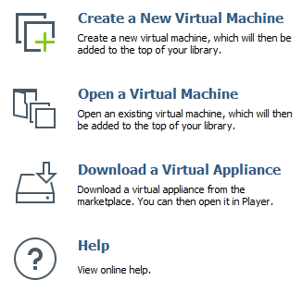

At the first screen in the wizard, select the “Installer disc image file (iso) option and browse to the file you just copied to the D: drive and click “Next”

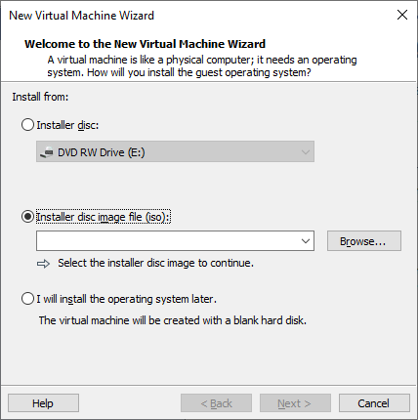

Name the virtual machine “PFSense” and click “Next”

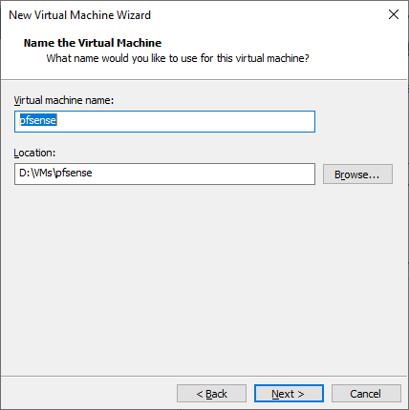

Leave the defaults for the disk, then click “Next”

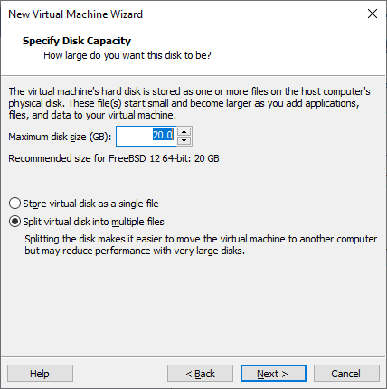

Click “Customize Hardware…”

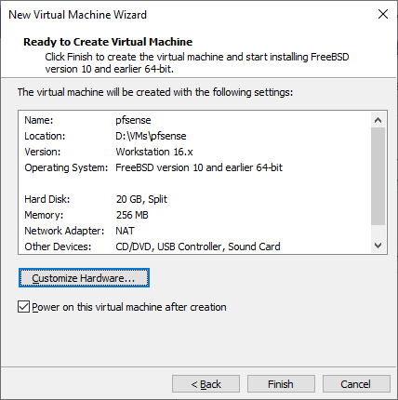

Select the Network Adapter and change it to “Bridged…”

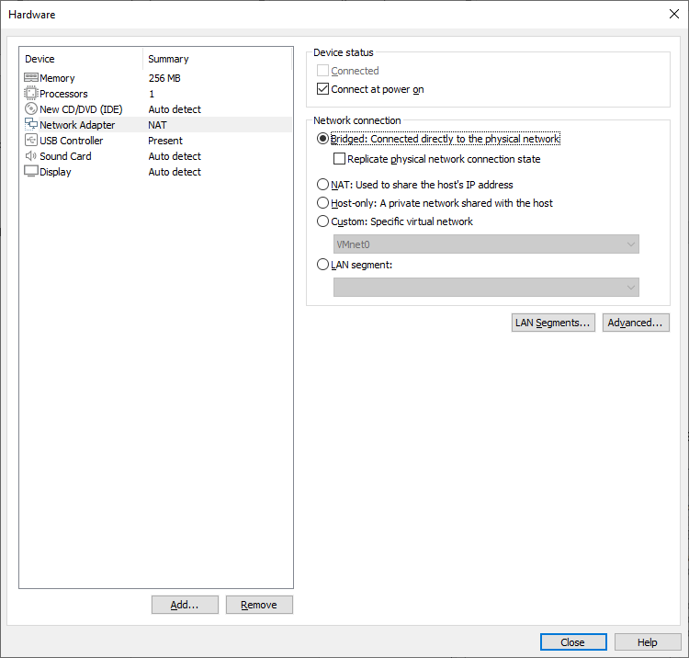

Then click “Add…” to add another network adapter. We are building a firewall and are not utilizing VLANs. Therefore we need at least two network adapters so that the firewall can filter traffic between the two network segments/subnets.

Choose “Network Adapter” and click “Finish”

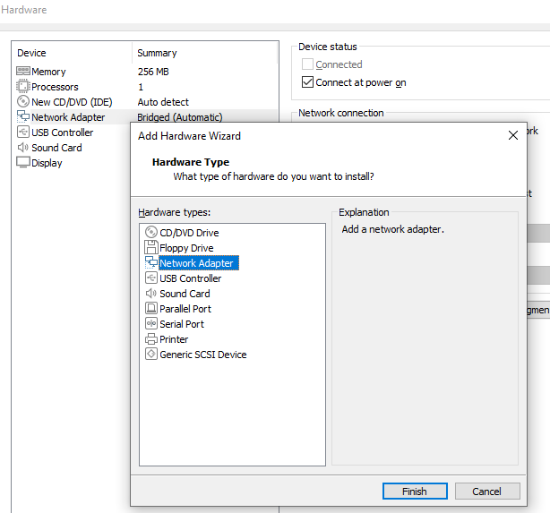

When the second adapter is added, choose “NAT” and click “Close”. We cannot choose bridged because that would put both interfaces in the same network segment.

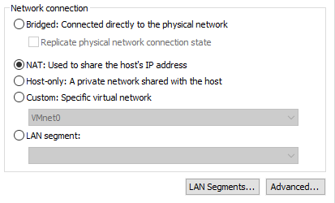

When your virtual machine settings look like the example below, click “Finish” to apply your changes and create the virtual machine

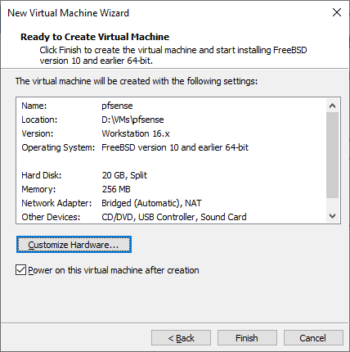

Your virtual machine may start automatically – If it does, simply pick up where the screenshots match below.

**Installing the Software**

If your virtual machine did not start automatically, go back to the VMWare Player window and locate the pfsense virtual machine you just created. Then click “Play virtual machine”

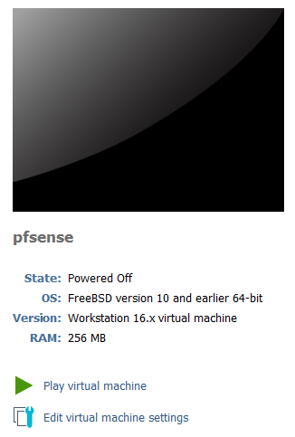

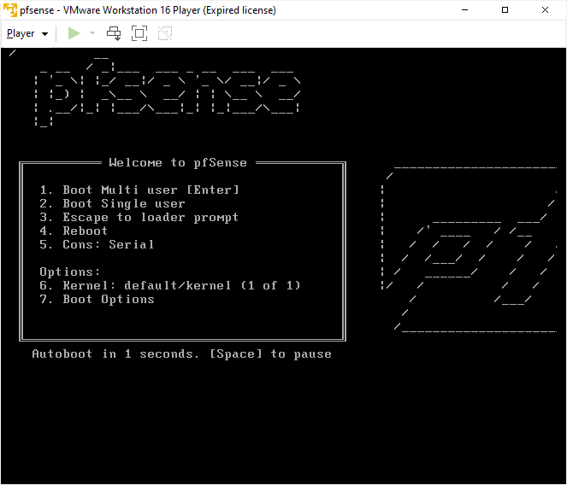

The virtual machine will boot off of the “CD/DVD” drive using the .iso file we specified.

Notice the popup in the screenshot – You can use the keyboard shortcut of **CTRL+**G (or click into the virtual machine window) to make the virtual machine respond to your keyboard or mouse. When this happens the keyboard and mouse will no longer respond on your host machine, which can be disorienting.

You then can use **CTRL+Alt** to give the keyboard and mouse focus back to the host machine you are using.

When prompted, press enter to accept copyright and distribution notice

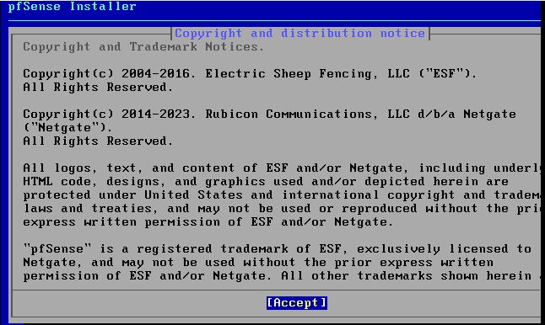.

Press “Enter” to begin the installation process.

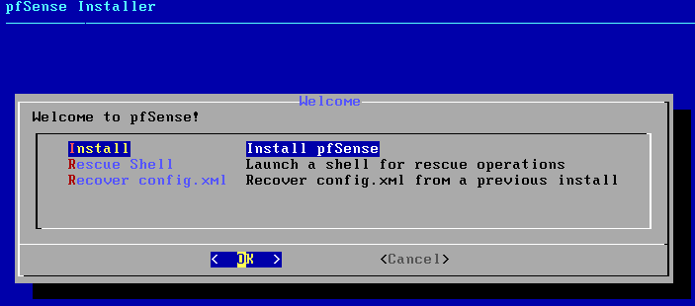

Press “Enter” to use the guided disk setup

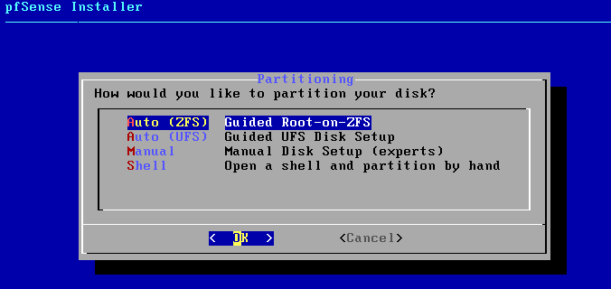

Press “Enter” to proceed

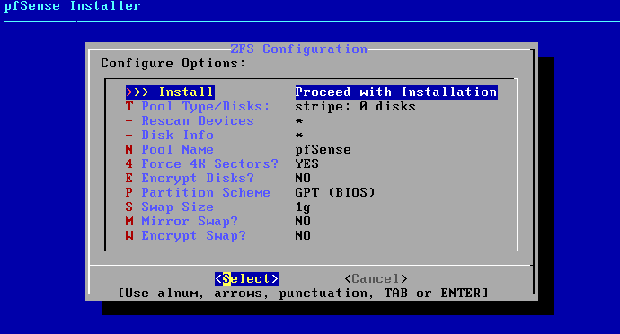

When prompted for a ZFS virtual device type, choose “stripe” – We only have a single disk, so this is the appropriate option

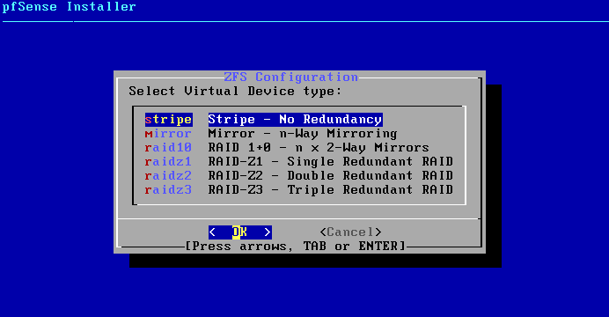

Press spacebar to select the *da0* disk for installation (when the disk is selected, an asterisk will show between the brackets)

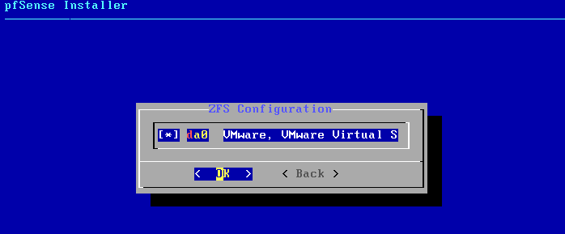

Then press “Enter”

Use the arrow keys to select “YES”, then press “Enter”

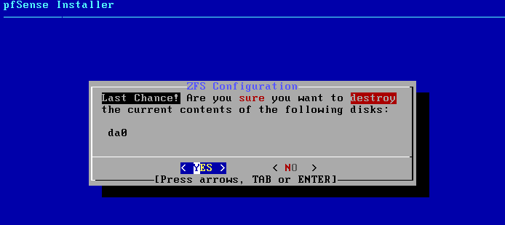

The installation of files will take a few minutes:

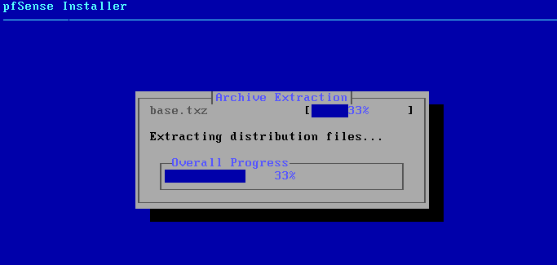

When the installation is finished, press “Enter” reboot and finalize the installation

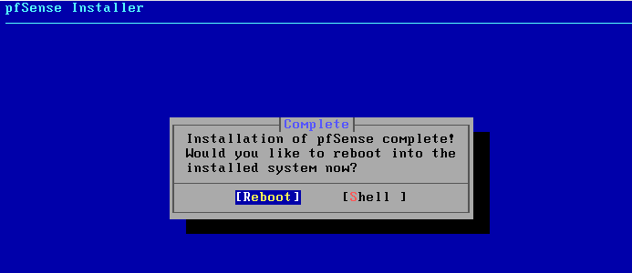

**Configuring Management**

When the machine boots, you may be presented with a message about VMware Tools:



Simply click “Never Remind Me” to make the message go away.

After rebooting you are presented with the pfsense console management screen. You should see the WAN and LAN information above the numbered menu options. In this case ‘*em0*’ has been selected as the WAN interface, and ‘*em1*’ has been selected as the LAN interface.

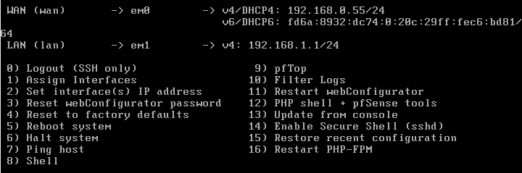

The WAN interface is the one that participates in the main classroom network. This will represent the “outside” of the firewall and the network that we are trying to protect the LAN network from.

If you look closely, you will see that the LAN interface has defaulted to the commonly used 192.168.1.1/24 value. **We need to change this value** to something that our physical computers can communicate with in order to use the web-based administrative page.

In order to determine the correct address to assign to our LAN interface, we need to determine the IP subnet configured on the **VMnet8** adapter. Use the ipconfig utility on the classroom computer to determine this value. In this example, the address is 192.168.184.1/24. We need to use an address within this same subnet on the LAN interface in PFsense.

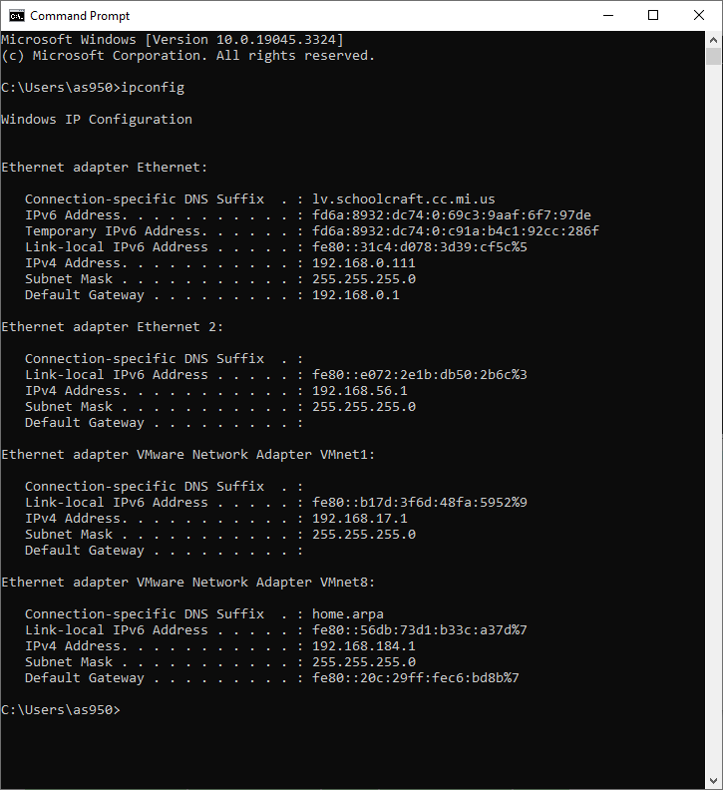

At the PFSense administrative console, press ‘2’ and then “Enter” to change the LAN interface IP address.

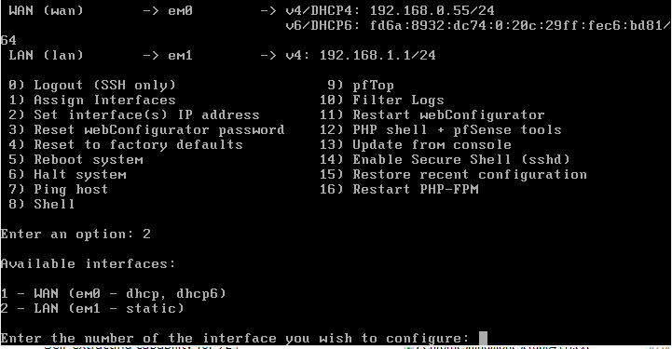

Choose the appropriate interface number to use (2).

Type “N” to skip DHCP configuration and set a static IP address.

When prompted enter **an IP address that shares the first 3 octets with the IP address that is configured on the VMnet8 adapter** (192.168.182.*2 in this example – yours will most definitely be different!*). Press “Enter” after typing the IP address

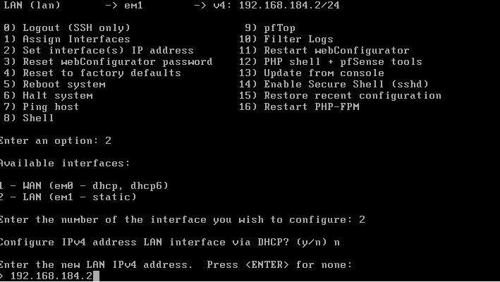

* When prompted, type ‘24’ for the number of subnet bits and press “Enter”.
* Type “n” to skip configuring DHCP6
* Press “Enter when asked about upstream gateway address and setting up IPv6.
* Type ‘n’ and then Enter when asked if you want to enable DHCP on the LAN interface. If you are asked about reverting to HTTP , type ‘n’ and then Enter

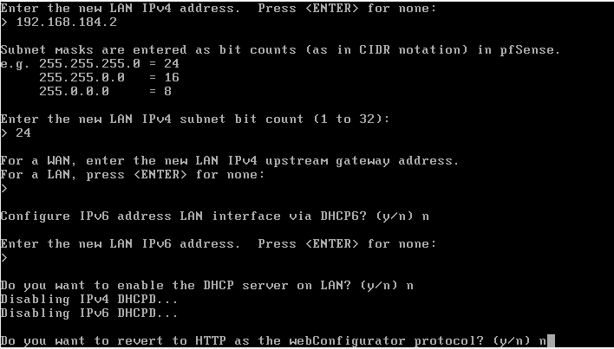

After the configuration is applied, you will see the https:// path to use to configure the PFsense administrative web page. In this case it is <https://192.168.184.2/>

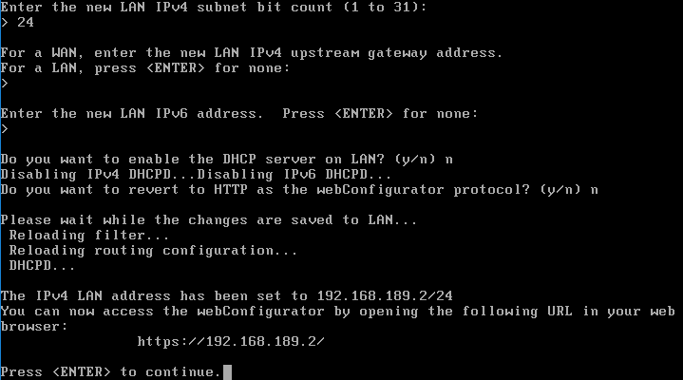

Type this address into a browser on your computer. If warned about self-signed certificates, click “ADVANCED”.

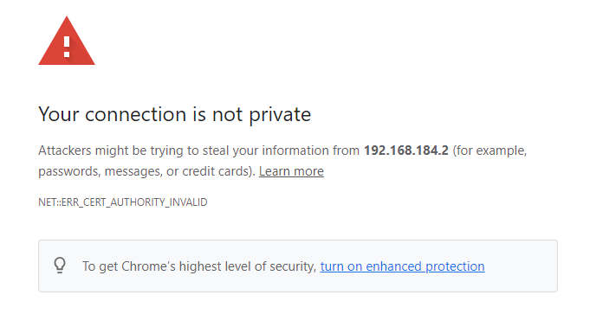

Then click “Proceed to 192.168.XXX.X (unsafe)”

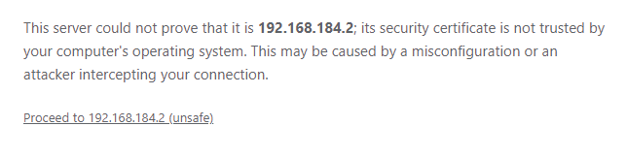

You are now at the PFSense administrative page! Type the default username of *admin* and password *pfsense*, then click “SIGN IN”

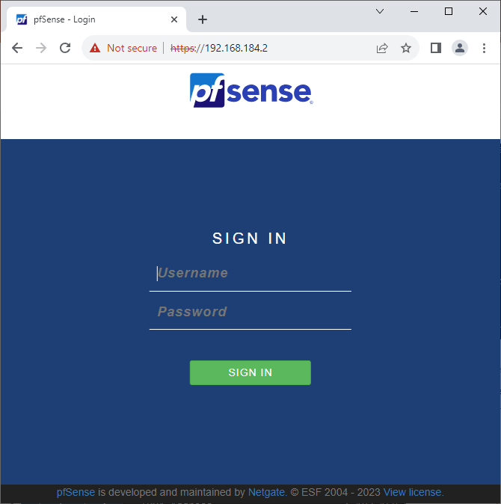

Click “Next” to start the initial configuration wizard

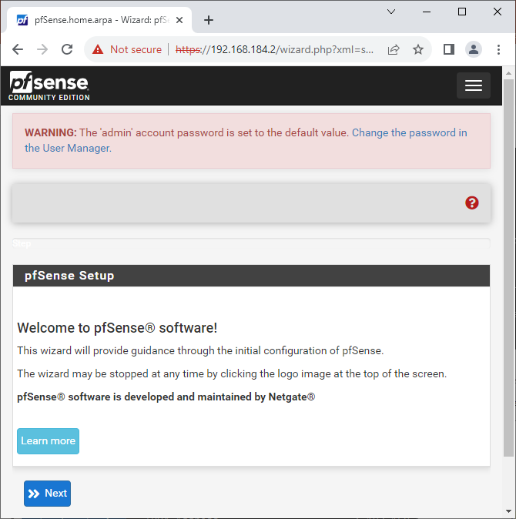

Click “Next” when prompted about pfSense support options

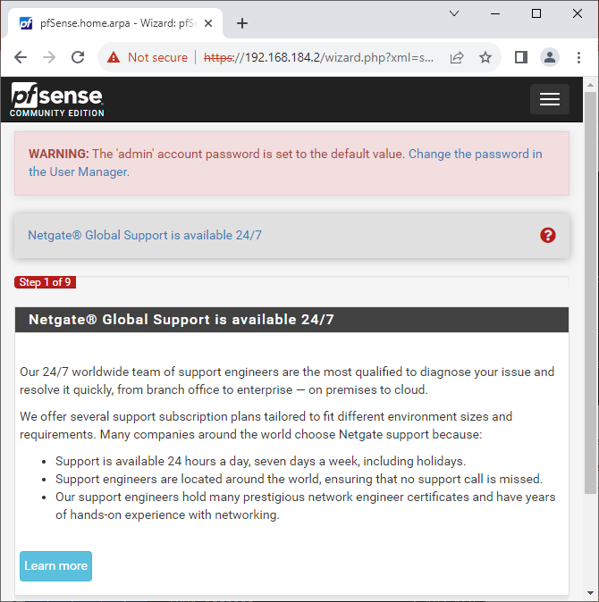

Type 192.168.0.1 as the primary dns server as shown below, then click “Next”­

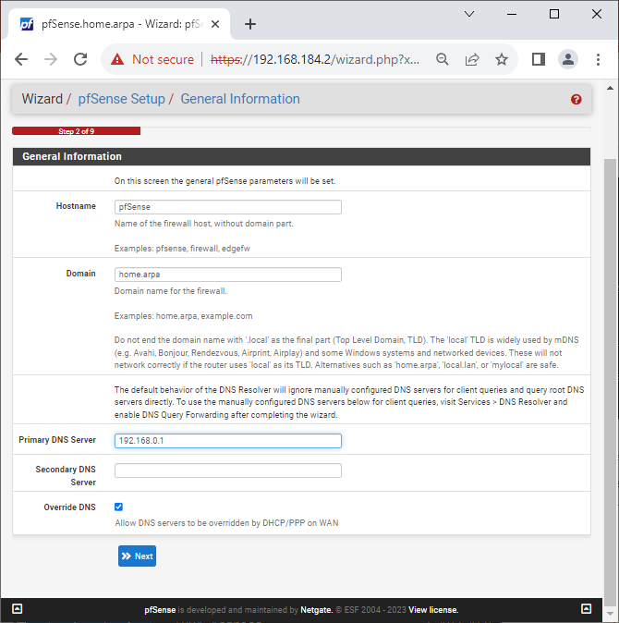

Keep the defaults for the Time Server Information. Scroll to the bottom of the page and click “Next”

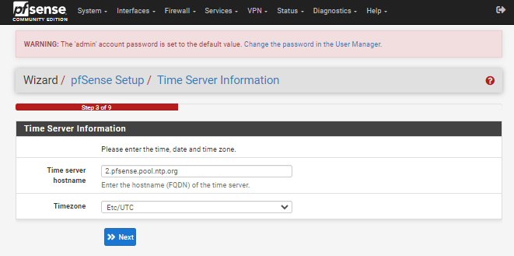

Keep the defaults for the WAN configuration. Scroll to the bottom of the page and click “Next”

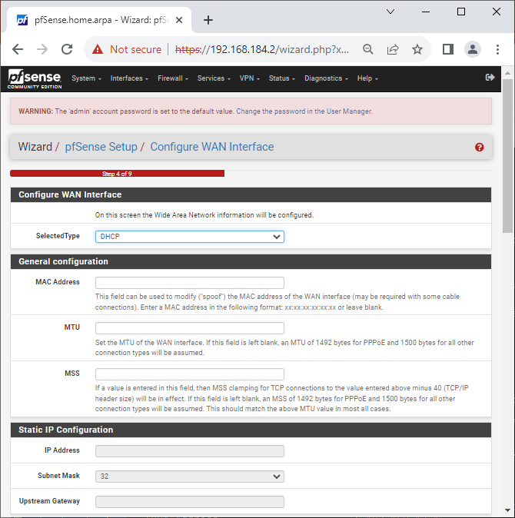

Keep the defaults for the LAN configuration. Click “Next” 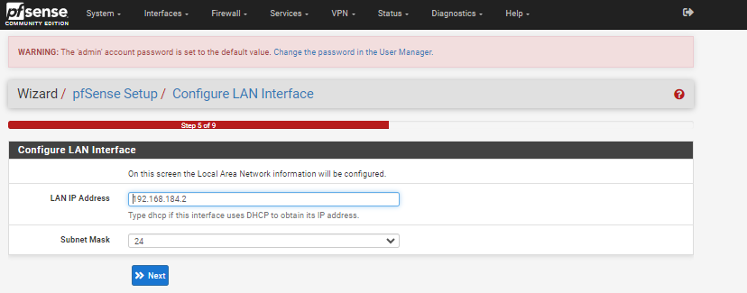

We will keep the default password of ‘pfsense’ (no quotes). Type that and click “Next”

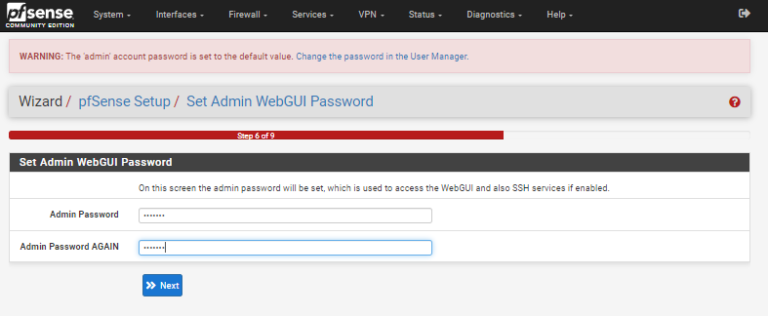

When prompted, click “Reload” to apply all of the settings.

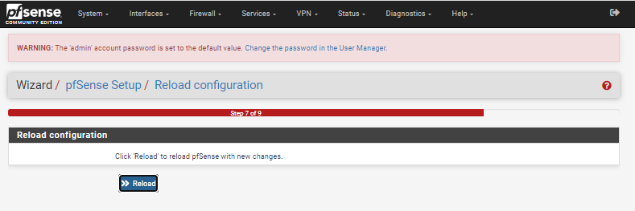

After the system reloads, click “Finish”

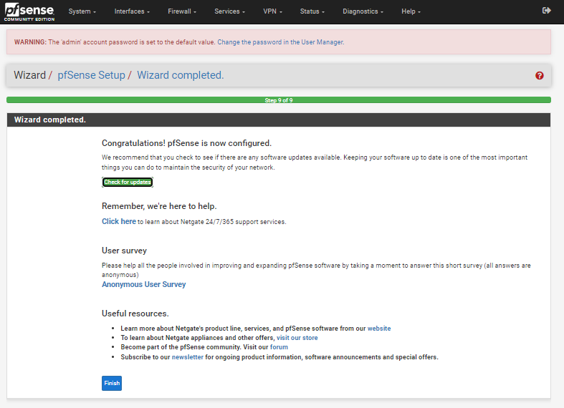

If you receive a copyright notice, click “Accept” and then “Close”

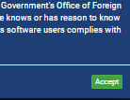

You should now see the main dashboard page of pfsense. From here we can start configuring the firewall!

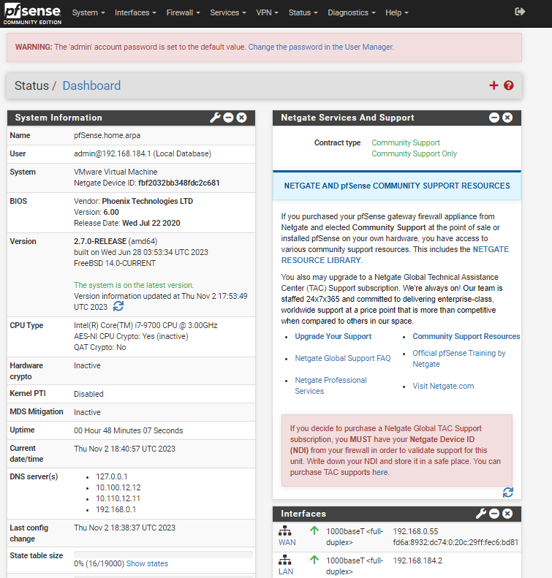

**Once you have completed the install, answer the questions on the Activity 2 Answer Sheet to learn more about pfSense.**